# Final Report

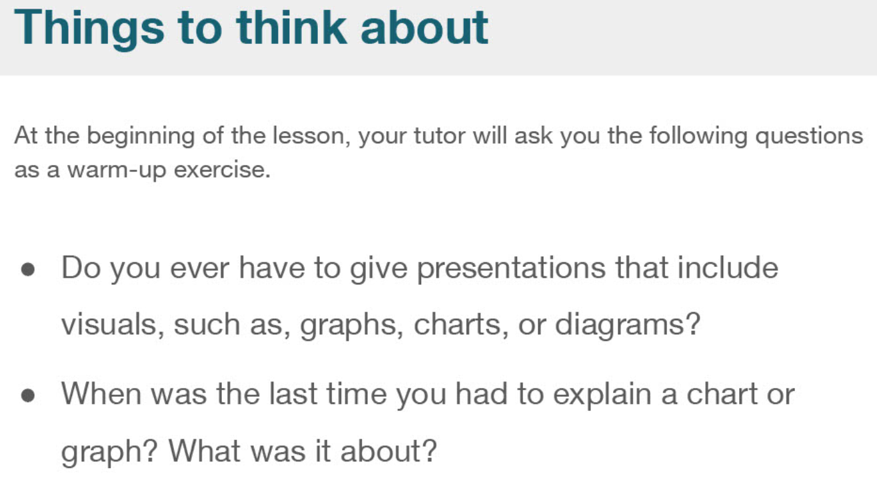

|  |  |  |
| --- | --- | --- |
| Presentation  Graph, chart, diagram |  |  |
| trend |  |  |
| substantial |  |  |
| To increase |  |  |
| To decrease |  |  |
| To remain |  |  |
| To illustrate |  |  |

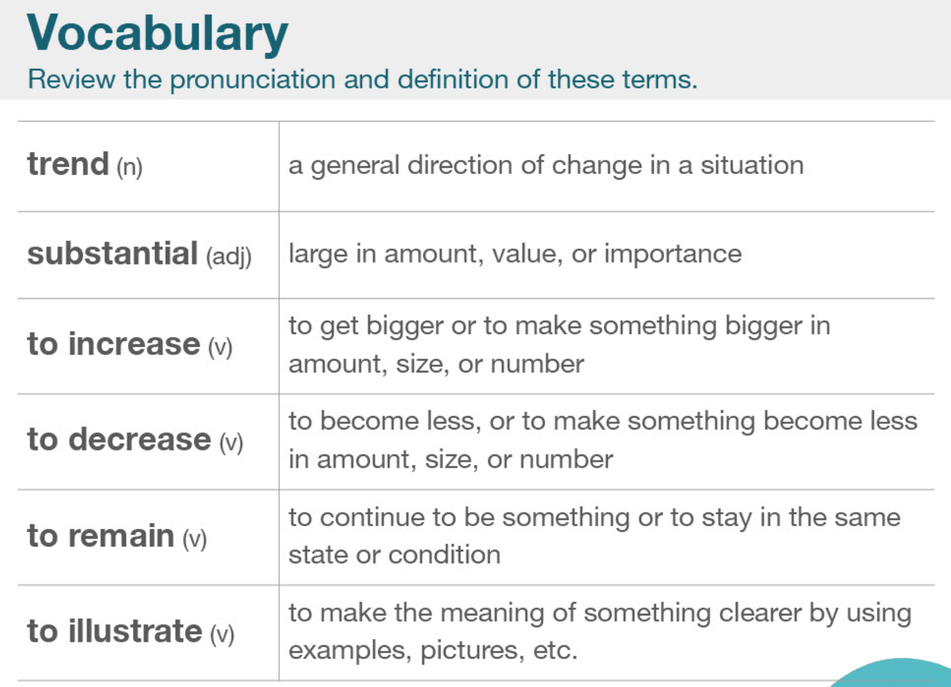

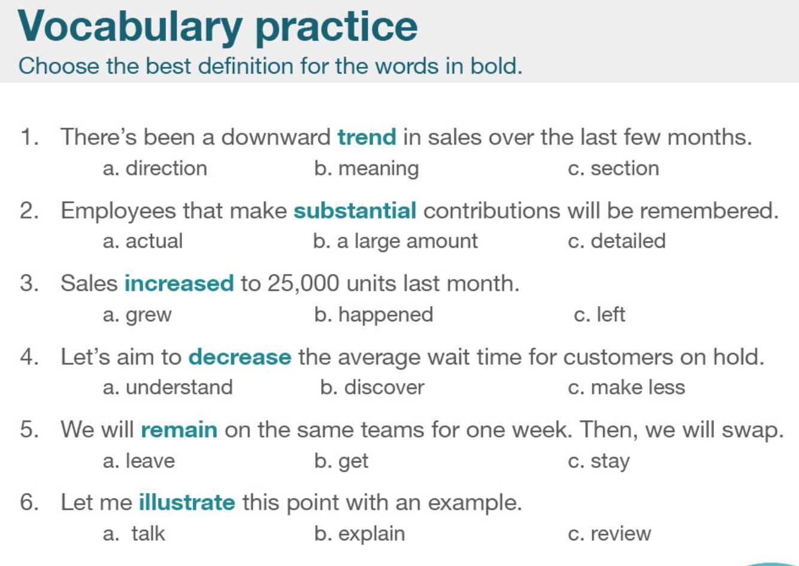

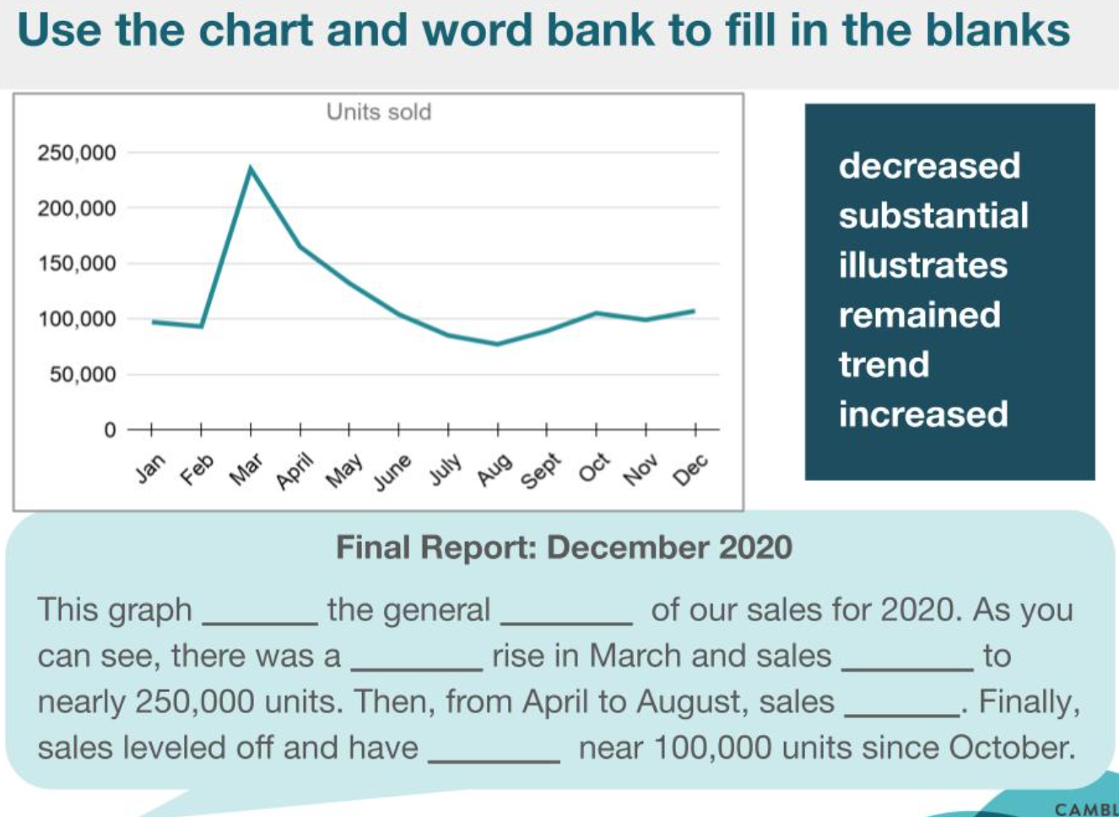

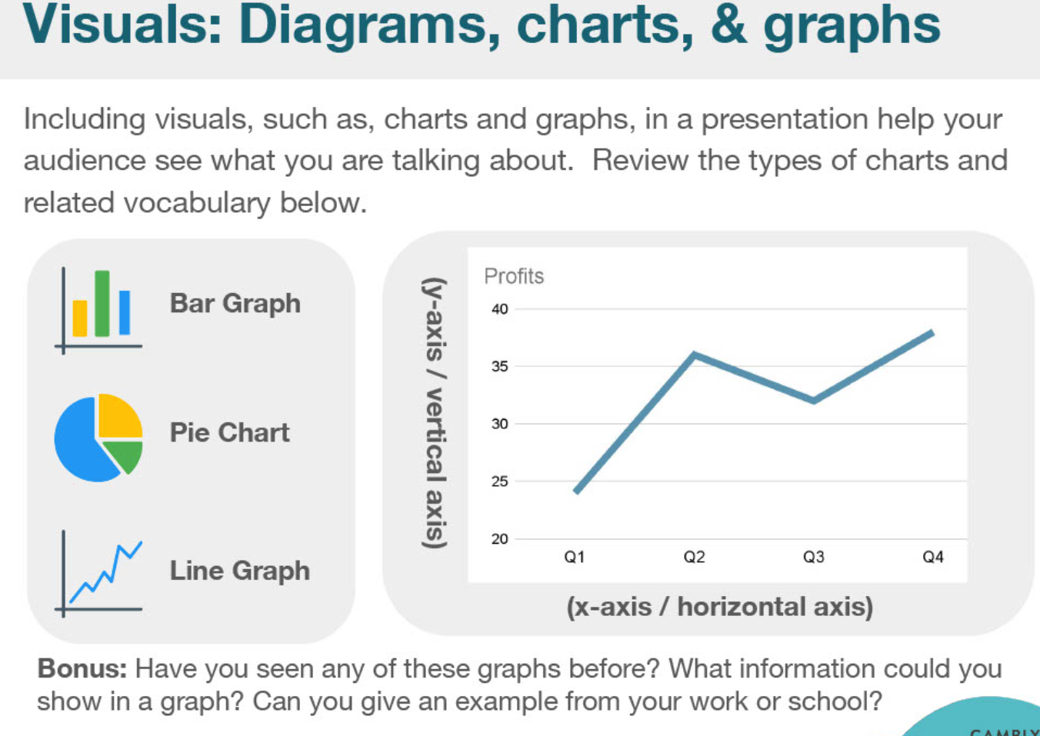

|  |  |  |
| --- | --- | --- |
| Bar graph |  |  |
| Pie graph |  |  |
| Line graph |  |  |
| Horizontal axis |  |  |
| Vertical axis |  |  |
| Curve  Line  percentage |  |  |
| visual |  |  |
| diagram |  |  |

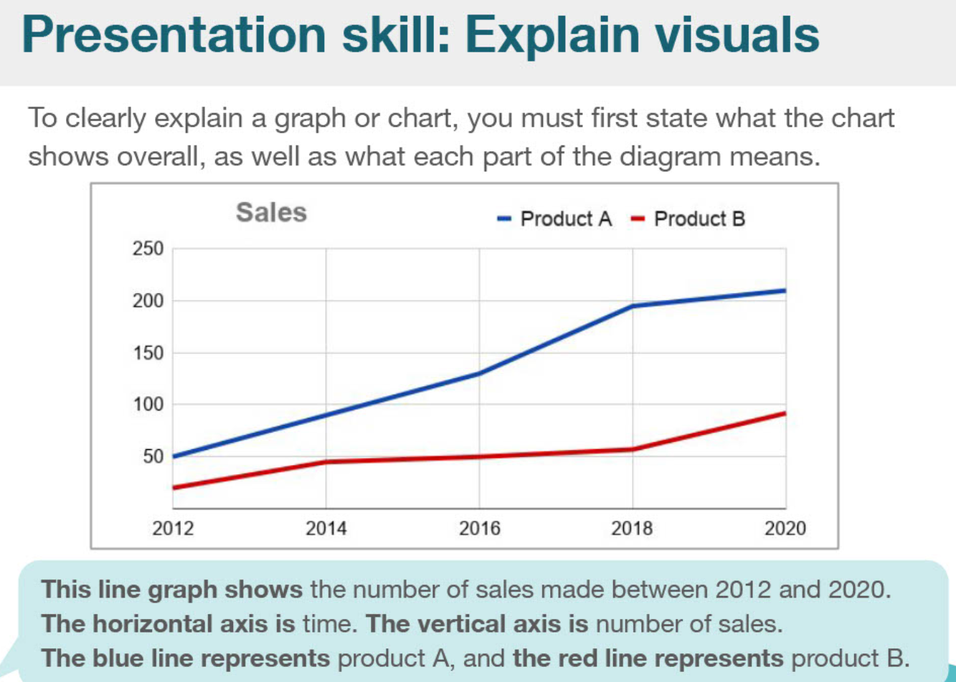

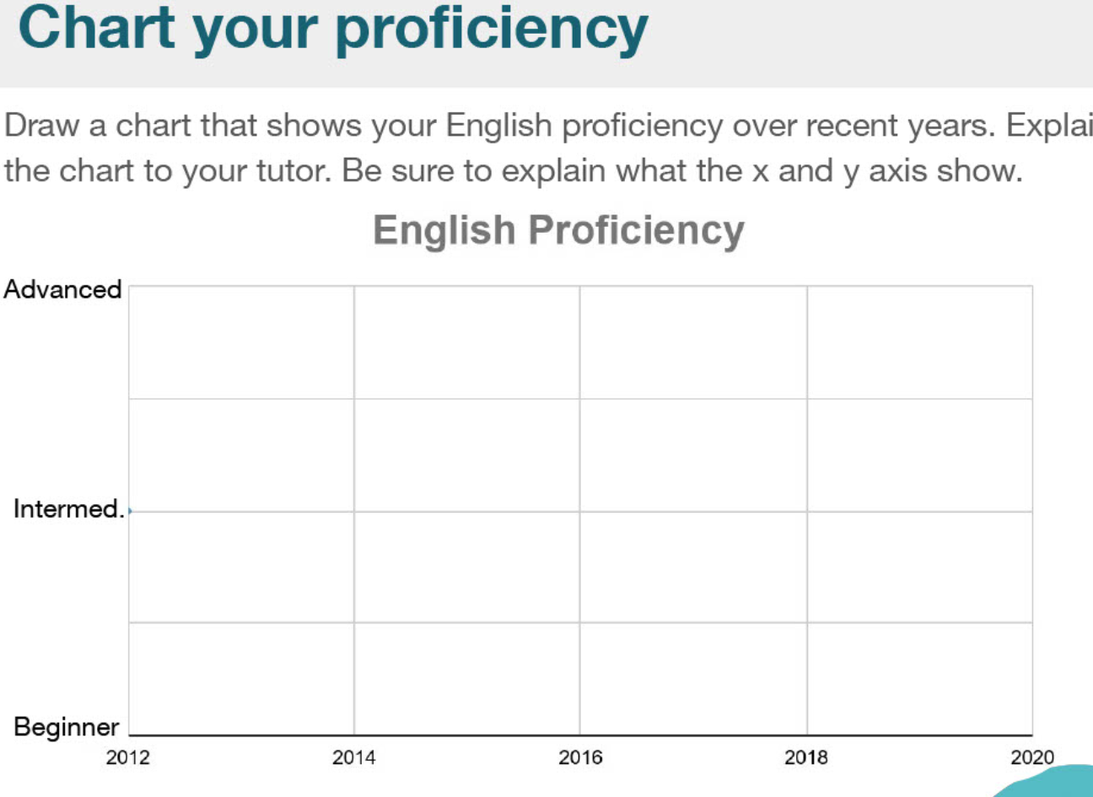

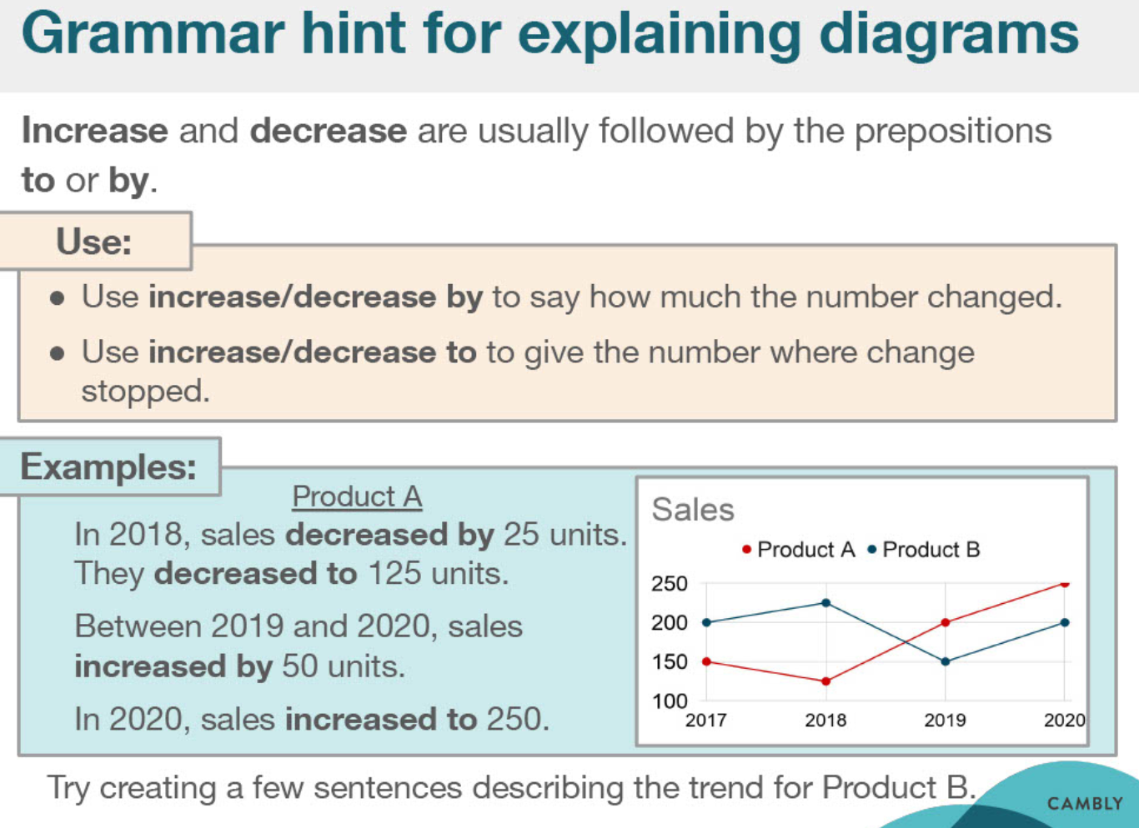

|  |  |  |
| --- | --- | --- |
| hint |  | an indirect suggestion |
| prepositions |  |  |
| units |  |  |

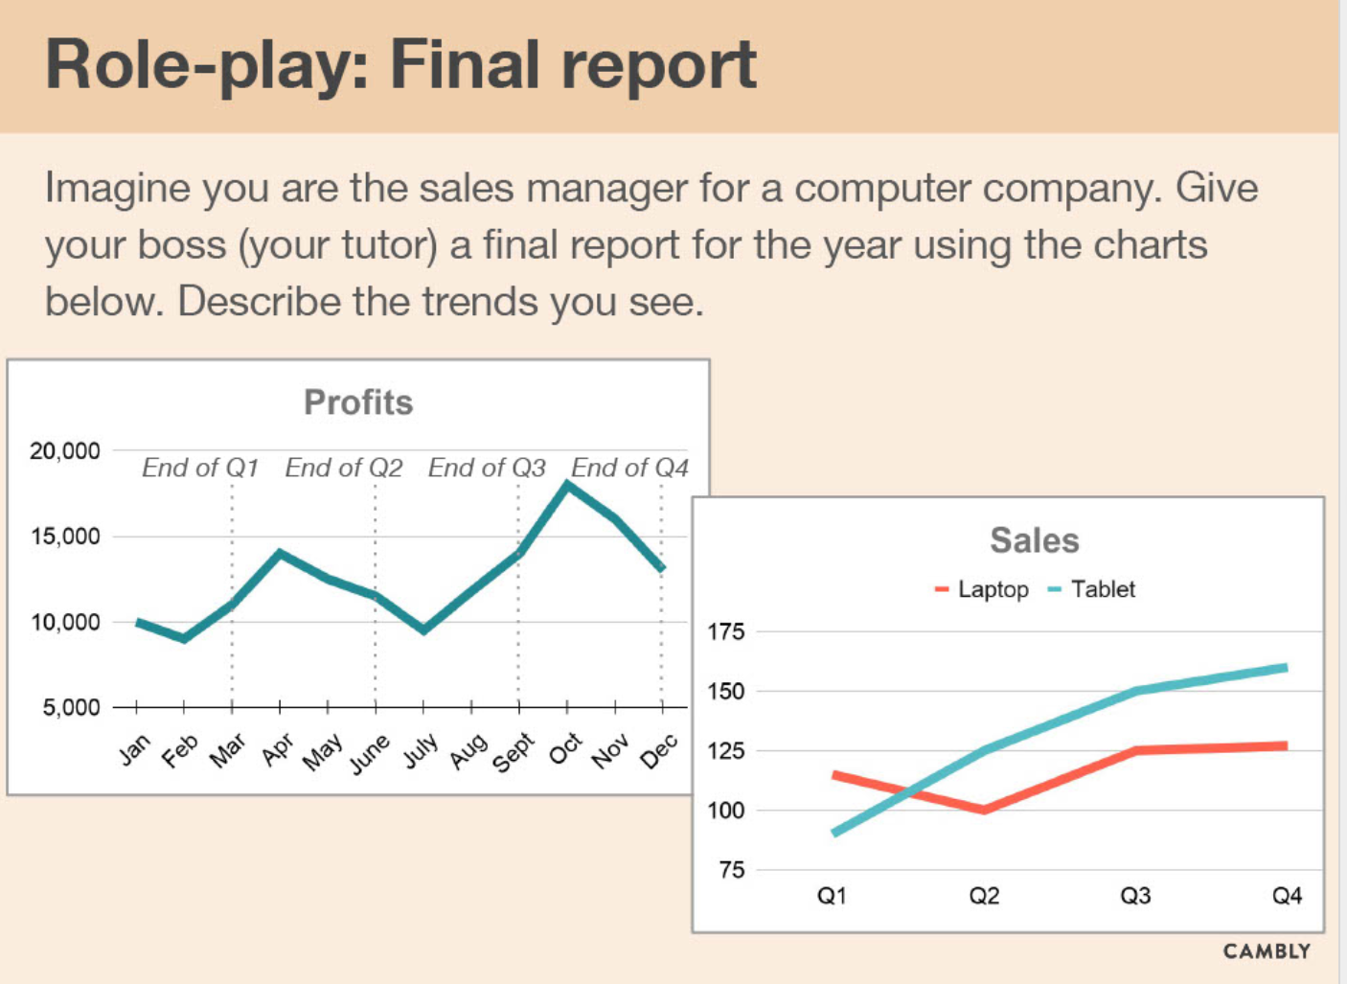

# Sale pitch

|  |  |  |
| --- | --- | --- |
| reliable  confident |  |  |
| etc  etcetera |  |  |
| advertising |  |  |
| 偏见 bias |  |  |
| market share |  |  |
| 70% = seventy per cent |  |  |

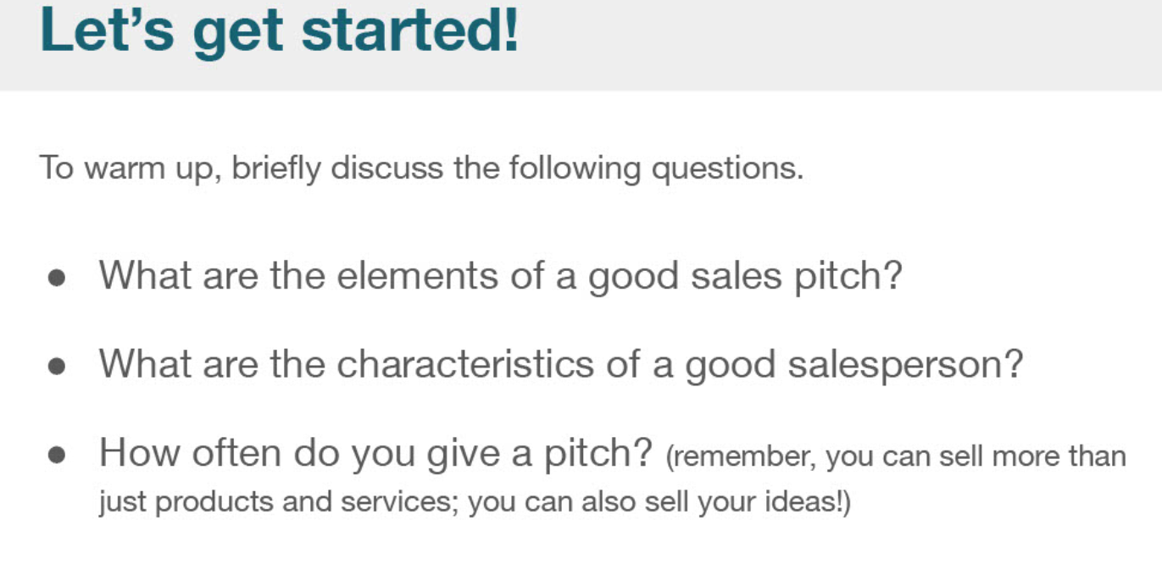

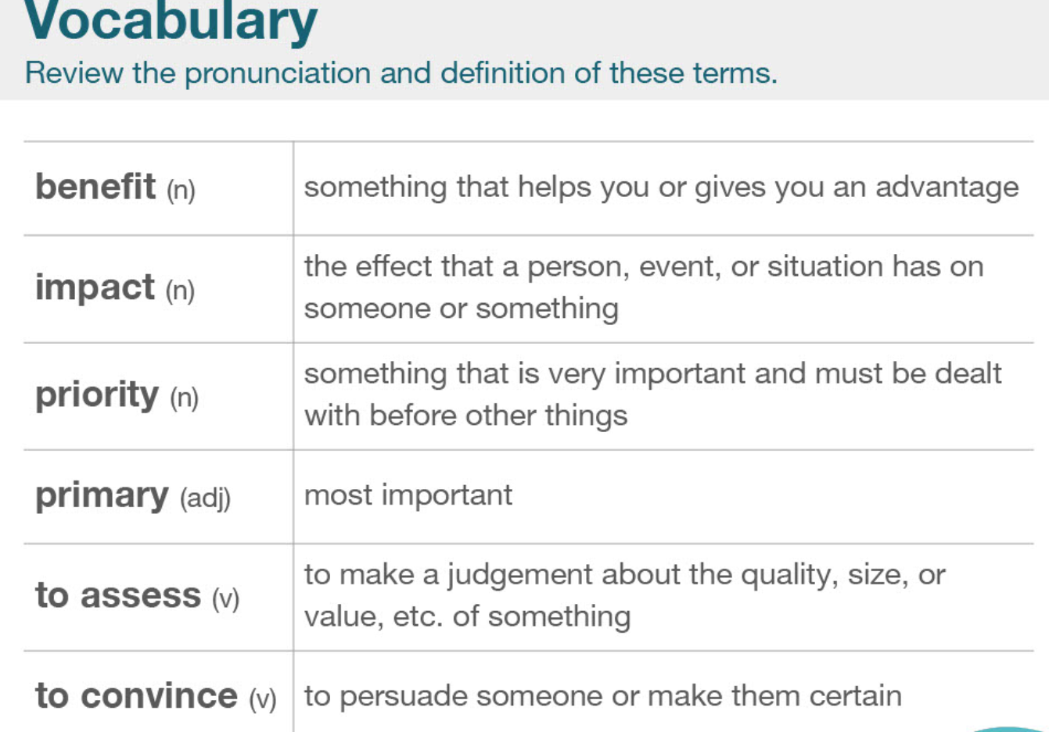

|  |  |  |
| --- | --- | --- |
| benefit |  |  |
| impact |  |  |
| priority |  |  |
| primary |  |  |
| To assess |  |  |
| To convince |  |  |

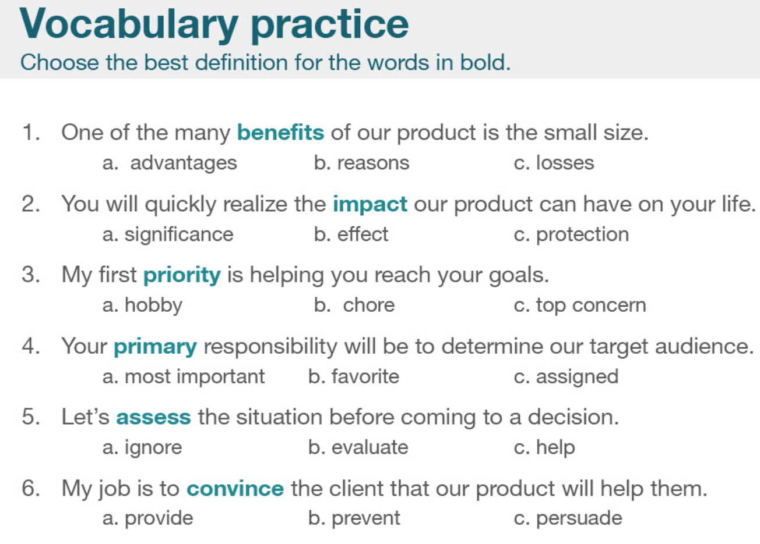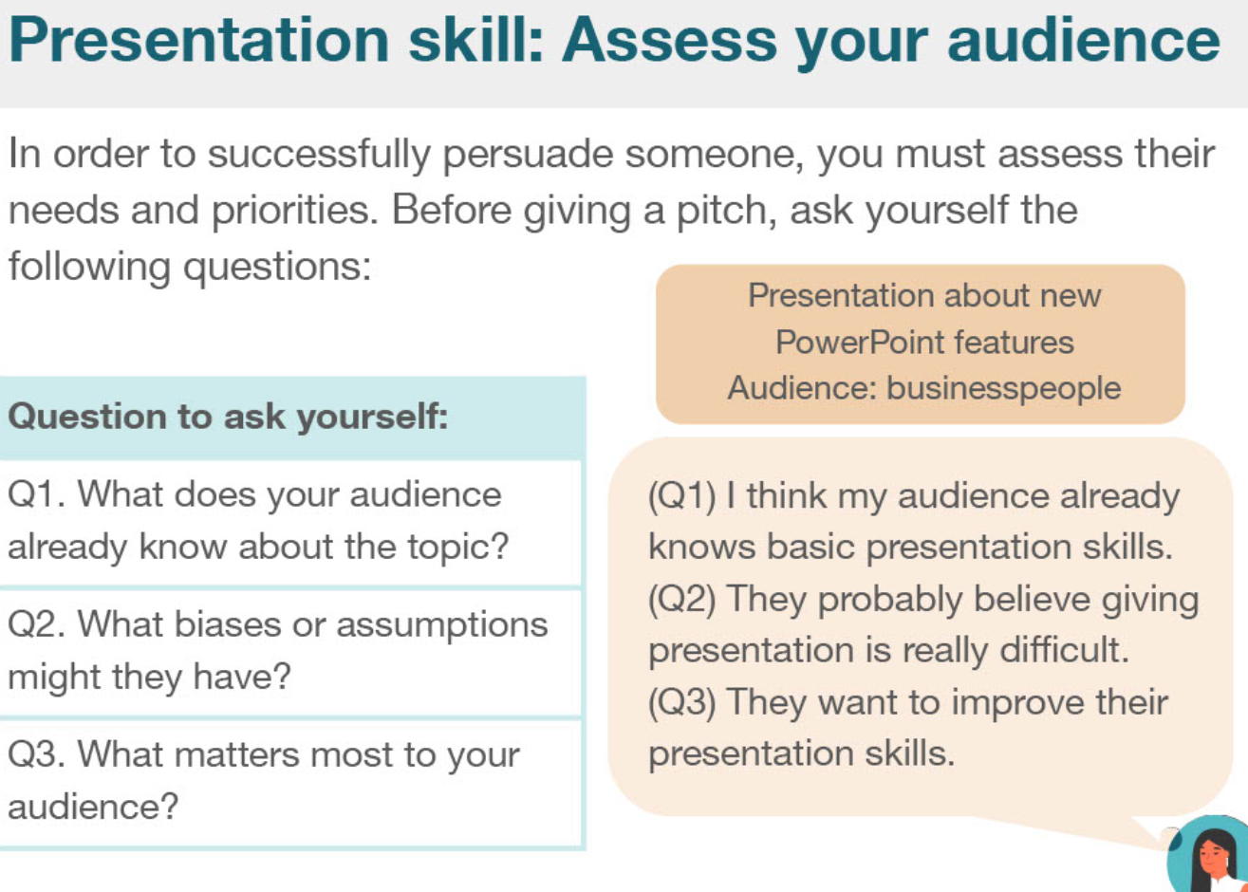

|  |  |  |
| --- | --- | --- |
| audience |  |  |
| presentation |  |  |
| Bias  assumption |  |  |
|  |  |  |
|  |  |  |
|  |  |  |

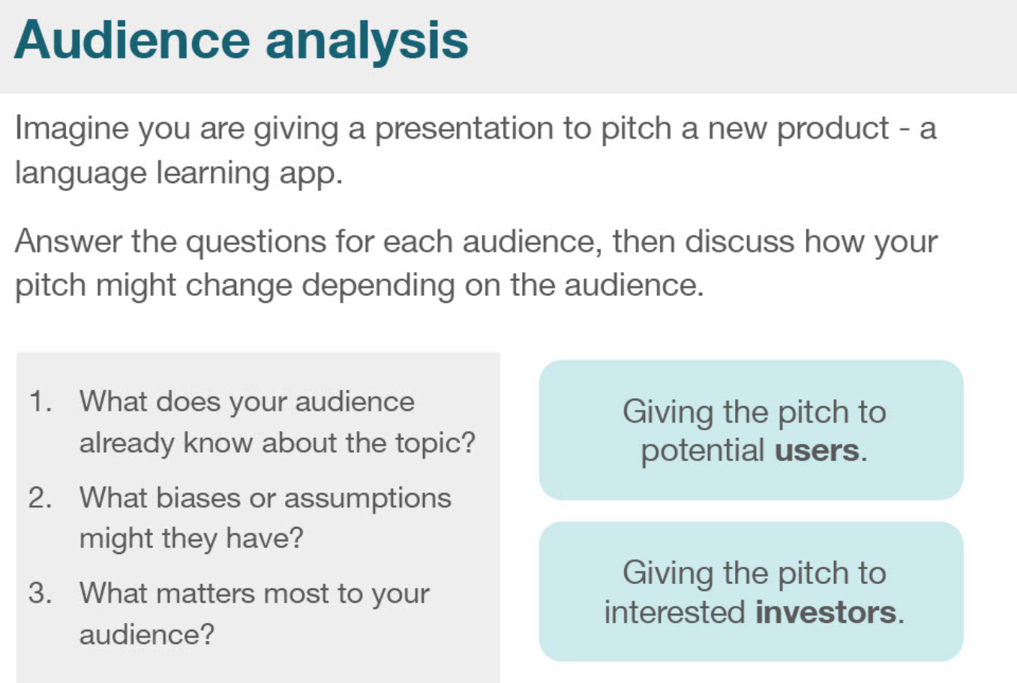

|  |  |  |
| --- | --- | --- |
| Potential users |  |  |
| Interested investor |  |  |
|  |  |  |

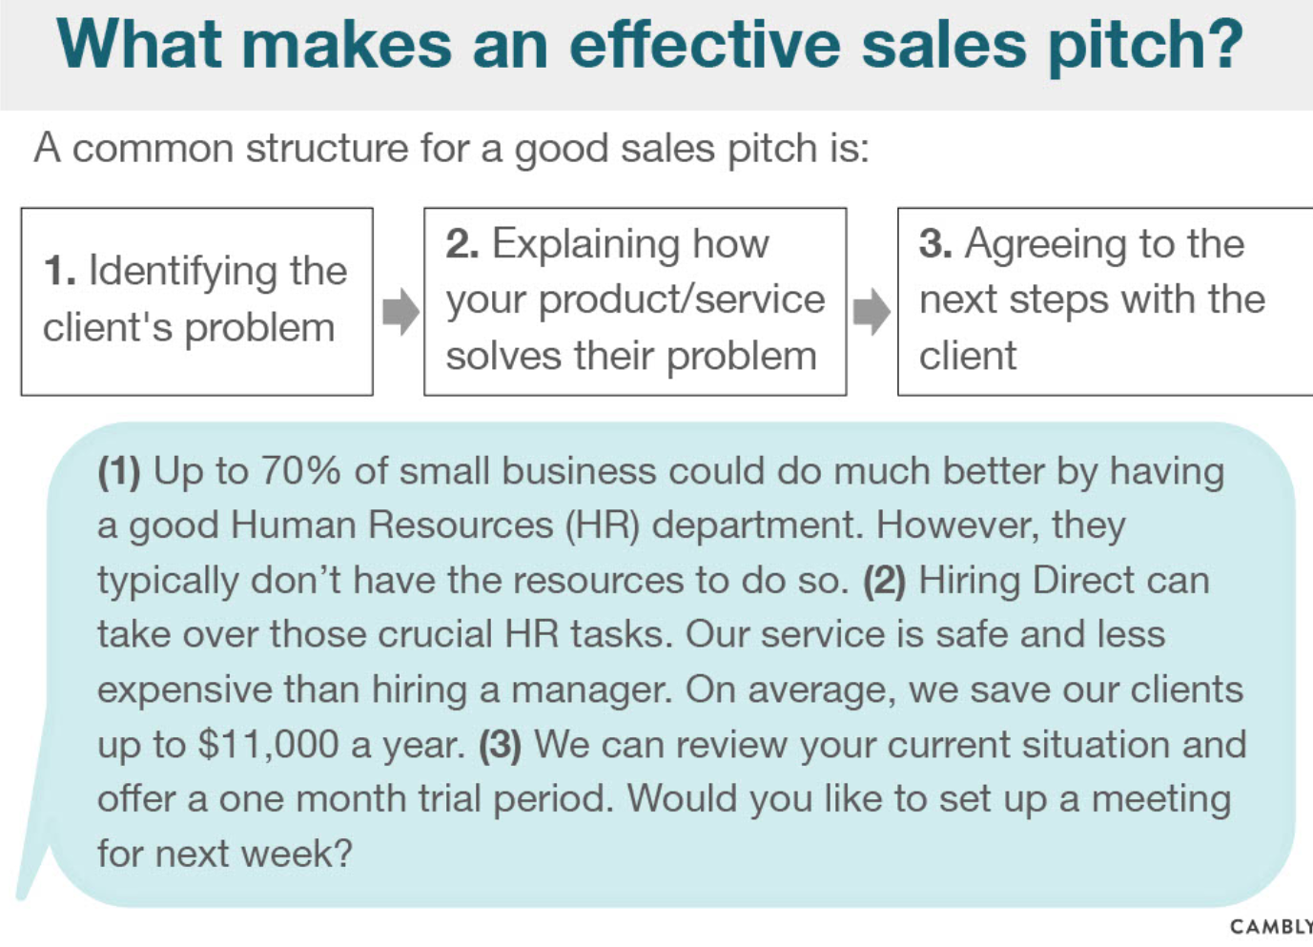

|  |  |  |
| --- | --- | --- |
| Human Resources department |  |  |
| Hiring  Crucial=important |  |  |
|  |  |  |

